Proposal for replacement of batik artwork with new display space

1. Background

The batik at the back of the worship area at St Mark’s Church was a piece of schoolwork created by the daughter of former members and given to the church to be displayed around the time the church was opened in the 1980’s. It is attached to a basic backboard with a simple wooden frame which is fixed to the wall. The backboard is now a little warped in places (not sitting flat against the wall) and the batik itself looks a little tired and faded.

2. The context of the proposed change

The worship space has a subtle but undeniable influence on our gathered worship. We are fortunate to have a lovely light area and some beautiful windows at the front. We also have some lovely handmade banners which add to the space. All these things speak of our worship and convey something important about who we are and what we value to all sorts of other groups that hire the space.

Beauty helps us into worship, and that worship can be expressed in many ways in return. We often focus in churches on music and we equip ourselves to do this well, however creative/visual art as worship is also important. The proposal is for a dynamic space that will be an attractive frame to display seasonal and community art which is fitting as part of our worshipping area.

3. The proposal

To replace the batik, we plan to construct a wooden frame of the same width and height with removable fabric backing and threaded hoop and eye fittings as a community art and display area for the church. (See photos for original spark of idea and mock up)

The frame will be constructed by Will Hooper, who has made several items of furniture for our worship space. He has provided costings (attached) and will make more detailed drawings for the faculty application if the PCC is happy to proceed. We hope to have this ready as part of our 40th celebrations next year (Feb 2027).

The plan for the original artwork would be to remove the frame and backboard and archive the batik itself with notes on its history.

- Consultation

There is no remaining contact with anyone connected to the batik, and when consulted with previously about removing it there were no objections. However, now that the proposal is more fully developed, if approved by the PCC, there will be additional consultation and sharing of the new proposal with members of St Mark’s Church before the faculty application is completed.

Photos
The original batik in question…
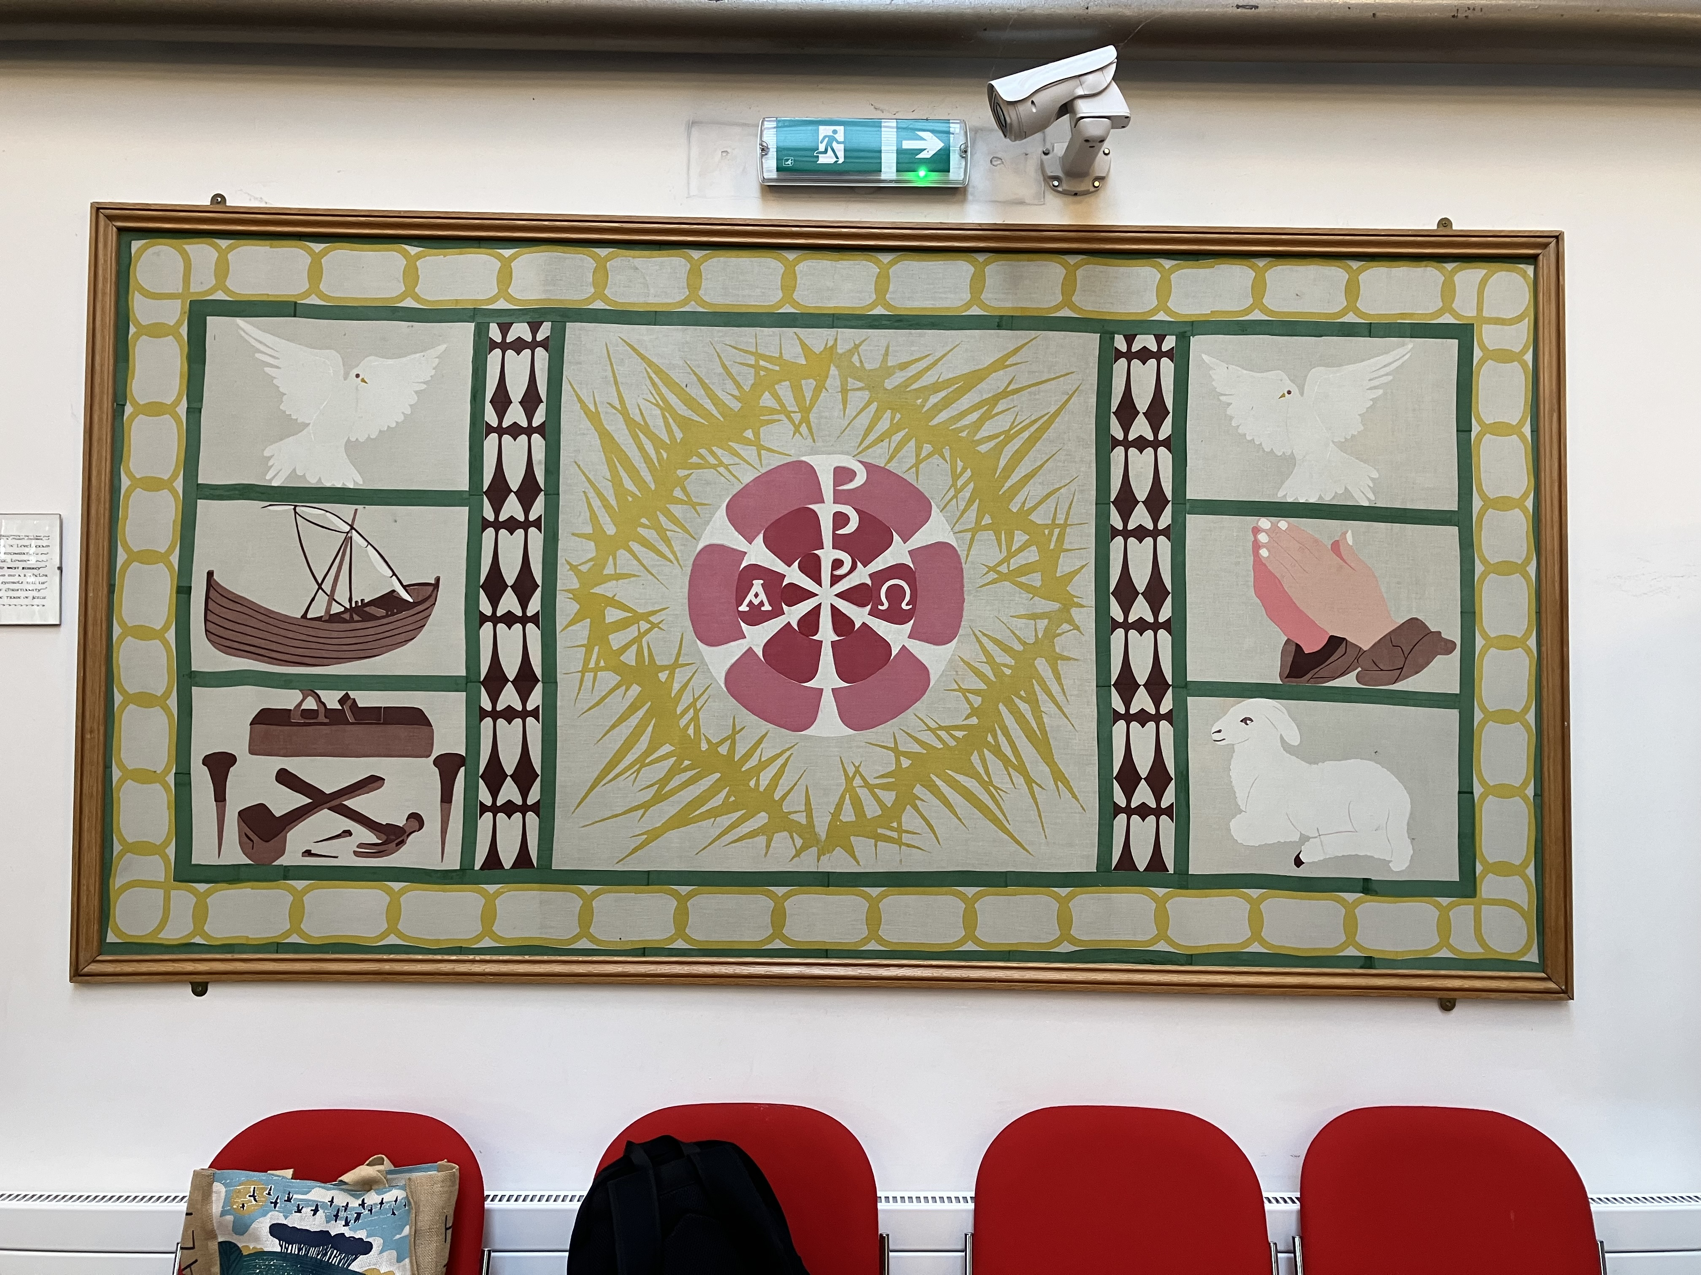
The original spark of an idea at a flower festival (below)…
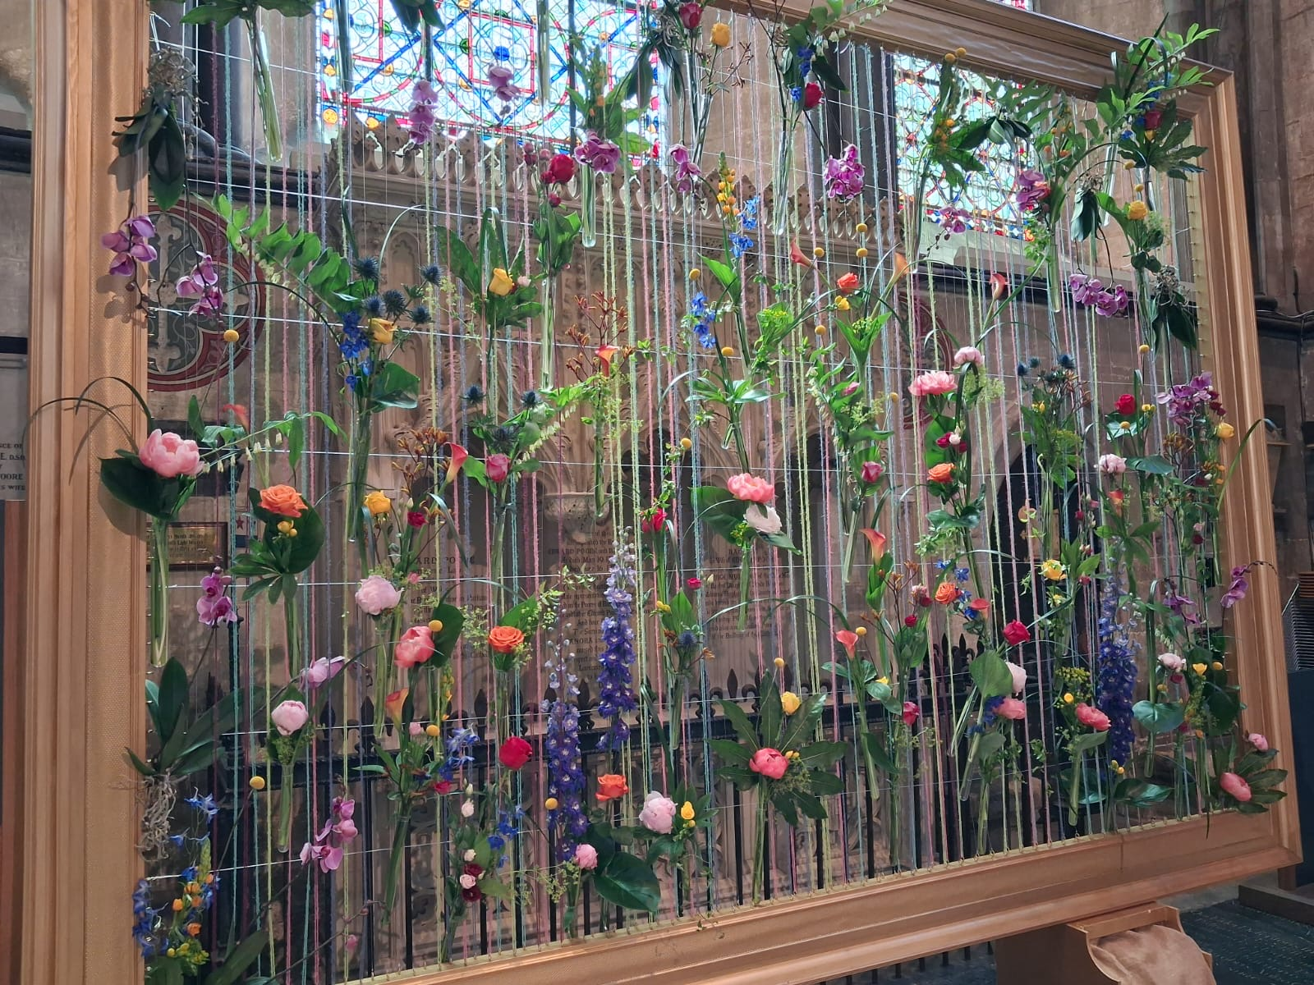
The mock-up… hook eyes will be hidden behind front of frame at intended scale…
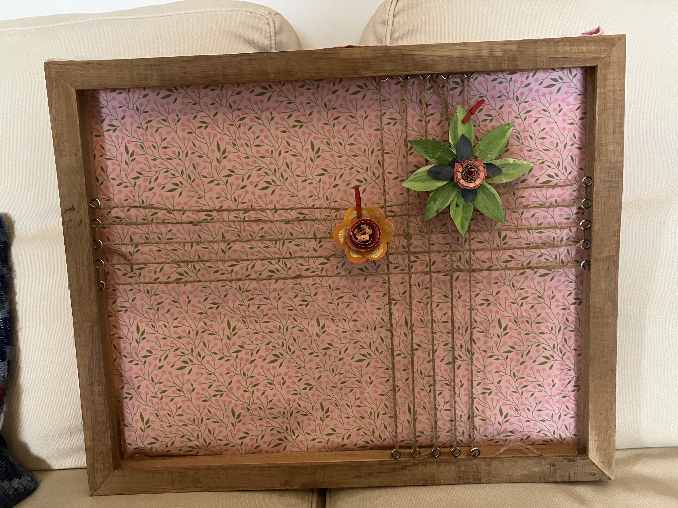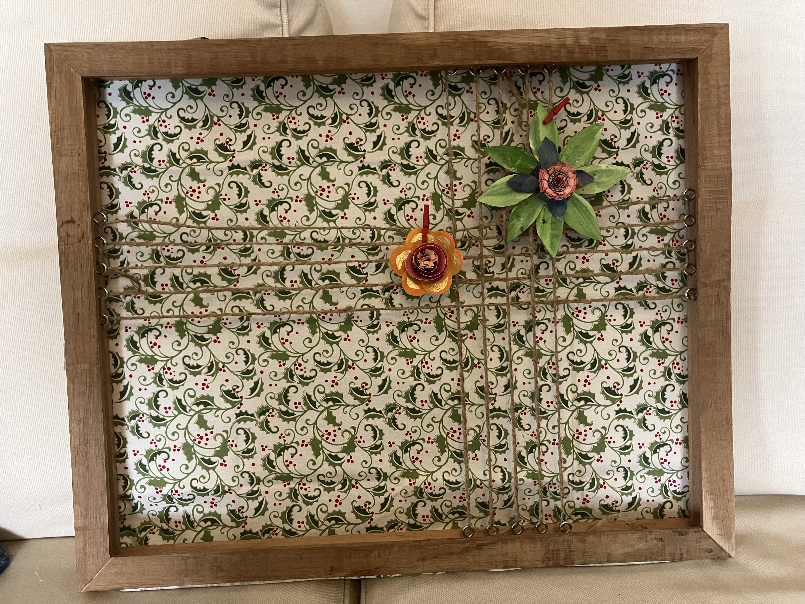
Summer and winter backings- partially strung for illustration. Type of strings and their positioning can also be varied, so it makes a flexible but attractive space.

Costing (estimated)

Wood for frame
Option 1- American White Oak (same as altar furniture)- £600
Option 2- European Oak (fine for the job)- £400

Eyelet hooks- under £10
Hook and loop tape - 4-7.5 metres needed? = £23.38 for 10m (Amazon)

Fabric for backing-
Standard fabric is not wide enough so my suggestion would be to adapt super king-size duvet covers- £32
We will want to build up a small collection of 4-6 backings for different seasons but can do this over time.

We already have twine, florist ribbon and fishing wire for stringing

Total- (estimate)- £465.38 for initial piece

With additional backings up to £160 over time?

It may be possible that people want to donate to the project.

